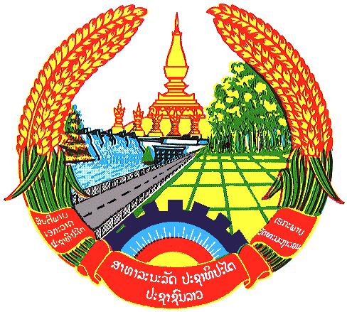

Statement by H.E. Kham-Inh KHITCHADETH, Ambassador and Permanent Representative of the Lao PDR
At the 30th Session of UPR Working Group
Geneva, 7-18 May 2018

Review of Cuba: 16 May 2018, at 14:30 - 18:00 hours

Mr. President,
Laos welcomes Delegation of Cuba to the 30th Session of the UPR.

We commend measures taken by the Government of Cuba to implement the previous UPR recommendations and congratulates its commitment to established policies and institutional framework for the promotion and protection of human rights.

Laos makes three recommendations:

- Strengthen the link between universities and research institutions with productive centers, as a contribution of education and science to the development of the country;
- Increase the knowledge of workers in different sectors of the economy of their labor and social security rights, and the mechanisms, ways and resources to enforce them, and
- Improve and strengthen the national network of institutions that benefit and protect older persons.

I thank you, Mr. President.

