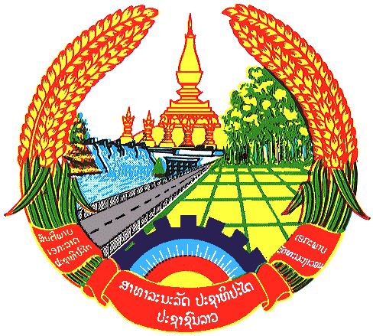

Statement by the delegation of the Lao PDR
At the 30th Session of UPR Working Group
Geneva, 7-18 May 2018

Review of Bangladesh: 14 May 2018, at 09:00 - 12:30 hours

Mr. President,
My delegation welcomes the Distinguish Delegation of the Bangladesh to the 30th Session of the UPR Working Group and would like to thank for its comprehensive National Report on human rights.

The Lao PDR commends measures taken by the Government of Bangladesh for its implementation of human rights treaty at national level which included the adoption of laws relating to rights of the persons with disabilities, protection against torture and child rights. We also wish to extend our congratulation for the development of the National Action Plan to prevent violence against women and children which will play a key role to ensure the protection and promotion of rights of women and children.

To conclude, The Lao PDR would like to make the following recommendations:

- Continue assistance and promotion on women’s empowerment in all sectors.
- Continue to tackle sexual violence against women to ensure protection of women’s rights and
- Facilitate the access to education, healthcare and public service for persons with disabilities.

We wish Bangladesh all the success in its Third Cycle of UPR.

I thank you, Mr. President.

