Permanent Mission of Rwanda
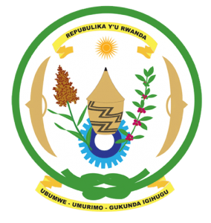
30th Session of the Universal Periodic Review Working Group

Review of the Russian Federation

14th May 2018

Statement delivered by Mr. Jean de Dieu Budurege

Thank you, Mr. Vice President,
- Rwanda warmly welcomes the delegation of the Russian Federation and thanks them for the presentation of their national report and the update just provided.
- Rwanda welcomes the positive steps that have been taken by the Russian Federation to implement the recommendations of its last UPR.
- While noting efforts to combat racial discrimination, Rwanda encourages the Russian Federation to adopt more proactive measures including through implementation of relevant anti-discrimination legislation.

Rwanda recommends that the Russian Federation:
- Strengthen measures to combat domestic violence in particular gender-based violence including through the adoption and implementation of specific legislation to ensure that cases of domestic violence are investigated and prosecuted.
- Ratifies the Second Optional Protocol to the International Covenant on Civil and Political Rights, aiming at the abolition of the death penalty, while welcoming the Russian Federations continued observation of a moratorium on the use of the death penalty and the adoption of relevant legislation.

We wish the Russian Federation a successful review.
Thank you

