Permanent Mission of Rwanda
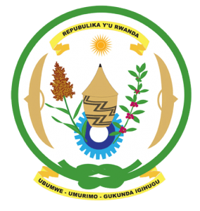
30th Session of the Universal Periodic Review Working Group

Review of Germany

8th May 2018

Statement delivered by Mr. Moses Rugema

Thank you, Mr. Vice President,
- Rwanda warmly welcomes the delegation of Germany and thanks them for the presentation of their national report and the update just provided.
- Rwanda welcomes the positive steps that have been taken by Germany to implement the recommendations of its last UPR including ratification of the UNCC and measures and policies to combat racial discrimination.
- While noting efforts to combat racial discrimination, Rwanda encourages Germany to adopt more proactive measures including through implementation of the National Action Plan against Racism to eliminate structural racial discrimination in all spheres

Rwanda recommends that Germany:
- Strengthen measures to promote gender equality, particularly with regard to the under-representation of women political decision-making positions, eliminating the gender wage gap and ensuring women and men have equal opportunities in the labour market.
- Strengthen its efforts to fight racism, including by enhancing institutional capacity to systematically document, investigate and prosecute racially motivated crimes.

We wish Germany every success in the implementation of the recommendations of this UPR. Thank you

