Permanent Mission of Rwanda
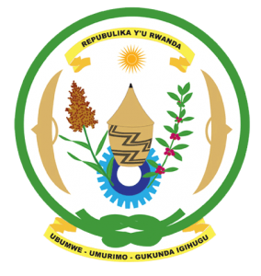
30th Session of the Universal Periodic Review Working Group

Review of Djibouti

10th May 2018

Statement delivered by

H.E. Dr. Francois Xavier Ngarambe

Ambassador and Permanent Representative

Thank you, Mr. Vice President,
- Rwanda warmly welcomes the delegation of Djibouti and thanks them for the presentation of their national report and the update just provided.
- Rwanda commends Djibouti for its continued efforts to promote and protect human rights and for the progress it has registered in improving the social and economic status of its citizens including through implementation of the Djibouti 2035 Vision and various policies and programs to combat and eliminate poverty.
- While noting the significant progress made in strengthening Djibouti’s National Human Rights Commission including in regard to its independence and the increase in its financial and human resources, we encourage Djibouti to enhance those efforts in order to bring the National Human Rights Commission in line with the Paris Principles.

Rwanda recommends that Djibouti:
- Strengthen implementation of legislation and policies aimed at ending harmful traditional practices in particular child, early and forced marriages and female genital mutilation and eliminate any loopholes in national legislation that might undermine the protection of women’s rights.
- Considers ratifying the Convention on the Prevention and Punishment of the Crime of Genocide
- We wish Djibouti every success in this UPR cycle.
I Thank you

