Permanent Mission of Rwanda
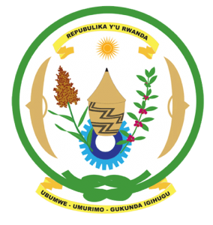
30th Session of the Universal Periodic Review Working Group

Review of Canada

11th May 2018

Statement delivered by Mr. Moses Rugema

Thank you, Mr. Vice President,
- Rwanda warmly welcomes the delegation of Canada and thanks them for the presentation of their national report and the update just provided.
- Rwanda welcomes the positive steps that have been taken by Canada to implement the recommendations of its last UPR. Rwanda commends Canada’s adoption of several programs and policies to advance gender equality and the empowerment of women.
- Rwanda encourages Canada to adopt more proactive measures to combat racial discrimination including through addressing incidences of racial profiling by law-enforcement and other government officials.
Rwanda recommends that Canada:
- Strengthen measures to protect victims of violence against women and girls, particularly among minority communities, including through ensuring access to quality multi-sectoral responses for survivors covering safety, shelter, health, justice and other essential services.
- Strengthen its efforts to fight racial discrimination, including by enhancing institutional capacity to systematically document, investigate and prosecute racially motivated crimes.

We wish Canada a successful review.
Thank you

