Permanent Mission of Rwanda
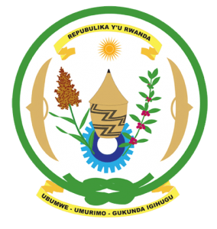
30th Session of the Universal Periodic Review Working Group

Review of Cabo Verde

8th May 2018

Statement delivered by Mr. Moses Rugema

Thank you, Mr. Vice President,
- Rwanda warmly welcomes the delegation of Cabo Verde and thanks them for the presentation of their national report and the update just provided.
- Rwanda welcomes the many positive steps taken by Cabo Verde to promote human rights and strengthen the institutional framework for the promotion and protection of human rights. In that regard, we welcome the positive steps taken by Cabo Verde, including approval of its National Gender Equality Plan, the extension of a standing invitation to the Human Rights Council special procedures mandate holders and its strengthened cooperation with the Treaty Bodies.
- While noting progress made in combating discrimination and violence against women, we encourage Cabo Verde to enhance those efforts through implementing relevant laws and eliminating any loopholes in national legislation that might undermine the protection of women’s rights.

Rwanda recommends that Cabo Verde:
- Strengthen implementation of legislation and policies aimed at the prevention and elimination of all forms of violence against women and to ensure that reports of domestic and sexual violence against women and girls are effectively investigated and perpetrators prosecuted.
- Consider ratifying the Optional Protocol to the Convention on the Rights of Persons with Disabilities.
We wish Cabo Verde every success in the implementation of the recommendations of this UPR. Thank you

