Permanent Mission of Rwanda
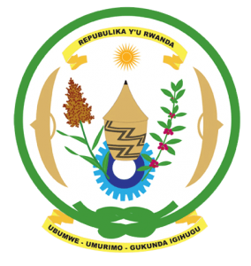
30th Session of the Universal Periodic Review Working Group

Review of Burkina Faso

7th May 2018

Statement delivered by Mr. Moses Rugema

Thank you, Mr. Vice President,
- Rwanda warmly welcomes the delegation of Burkina Faso and thanks them for the presentation of their national report and the update just provided.
- Rwanda commends Burkina Faso for its continued efforts to promote and protect human rights and for the progress it has registered in improving the social and economic status of its citizens in a complex political, security and socio-economic context.
- While noting progress made in combating discrimination and violence against women, we encourage Burkina Faso to enhance those efforts through implementing relevant laws, eliminating any loopholes in national legislation that might undermine the protection of women’s rights, in particular modifying discriminatory stereotypes that affect women. We further encourage Burkina Faso to expedite efforts aimed at the de facto abolition of the death penalty.

Rwanda recommends that Burkina Faso:
- Strengthen implementation of legislation and policies aimed at ending harmful traditional practices in particular child, early and forced marriages and female genital mutilation.
- Considers extending a standing invitation to all thematic Special Procedures of the Human Rights Council.
We wish Burkina Faso every success in the implementation of the recommendations of this UPR. Thank you

