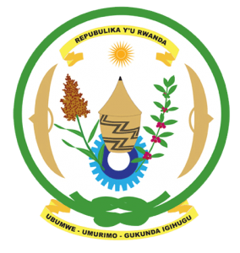
30th Session of the Universal Periodic Review Working Group
Review of Azerbaijan
15th May 2018

Statement by Rwanda delivered by H.E. Francois Xavier Ngarambe

Ambassador and Permanent Representative

Thank you Mr. President,
- Rwanda warmly welcomes the delegation of Azerbaijan and thanks them for the presentation of their national report and the oral update just provided.
- Rwanda welcomes Azerbaijan’s efforts to promote and protect human rights including through the adoption of various legislative and policy measures. We further commend Azerbaijan for its cooperation with the UN human rights mechanisms and treaty bodies.
- While noting efforts to combat discrimination, we encourage Azerbaijan to enhance measures and policies to address discrimination on all grounds including through strengthened implementation of existing legislation.
Rwanda recommends that Azerbaijan:
- Enhance efforts to address patriarchal attitudes and gender stereotypes through the strengthened implementation of relevant laws and policies.
- Strengthen measures to combat domestic violence and violence against women including through the implementation of legislation to ensure justice for victims.
We wish Azerbaijan every success in the implementation of the accepted recommendations of this review. Thank you.

