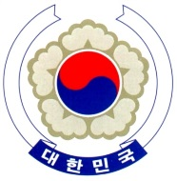

PERMANENT MISSION OF THE REPUBLIC OF KOREA
GENEVA

The 30th Session of the UPR Working Group <Check against delivery>
Review of Cameroon
Geneva, 16 May 2018

Statement of the Republic of Korea

Thank you Mr. President.

The Republic of Korea welcomes the distinguished delegation of Cameroon to the third cycle of the UPR.

Bearing in mind the progress made since the last cycle, today my delegation has the honour to present the following recommendations to Cameroon.

- Redouble the efforts for the full and effective implementation of the official bilingual policy, and ensure that the anglophone minority are not subject to inequality in their access to public services, administration of justice, and freedom of speech.

- Ensure that women have equal rights to nationality as men under the Nationality Code.

- Put an end to the practice of incommunicado detention and ensure that no person is deprived of liberties in secret or unofficial detention facilities.

We wish Cameroon a successful review. I thank you Mr.President. /END/

