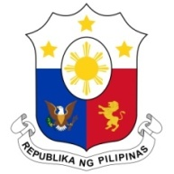
PHILIPPINES

Human Rights Council
Working Group on the Universal Periodic Review
30th Session, 3rd Cycle

UPR of UZBEKISTAN
Salle XX, Palais des Nations, Geneva
9 May 2018

Thank you, Mister Vice-President,

The Philippine delegation warmly welcomes the delegation of Uzbekistan to the 3rd Cycle of the UPR process. We note with appreciation the participatory process in the preparation of its national report.

The Philippines also welcomes the improvements in the normative framework for the protection and promotion of human rights in Uzbekistan. We note in particular the several amendments to the Constitution aimed at strengthening the defense of fundamental freedoms and human rights.

The Philippines commends Uzbekistan for its efforts to institutionalize protection of victims of trafficking, including the provision of medical and psychological support.

The Philippines recommends the following.

- Ratify ICMRW and ILO Convention 189;

2. Step up efforts in aligning its national human rights institution with the Paris Principles.

We wish Uzbekistan success in the continued implementation of its accepted recommendations.

Thank you, Mister Vice-President.

