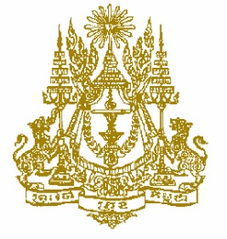

STATEMENT BY CAMBODIA
Review of Azerbaijan
30th Session of the UPR Working Group
15 May 2018 at 9.00 to 12.30 am

Mr. President,

- Cambodia warmly welcomes the Azerbaijan delegation to the 30th Session of the UPR working group and appreciate the very comprehensive national report presented.

- My delegation notes since the 2nd cycle of the UPR review process, the majority of UPR recommendations were accepted and widely implemented by Azerbaijan authorities. We applauded Azerbaijan for the progress made in implementing recommendation during the 2nd UPR cycle for the promotion and protection of human rights in the country. Azerbaijan is a state party to the majority of the core international human rights conventions and humanitarian instruments, and cooperates closely with the UN human right mechanisms and special procedures, promotes bilateral dialogues with countries at the regional level for the human rights advocacy.

- Azerbaijan has shown its interests in supports the special procedures process of the human rights council, and extending invitations to the special rapporteurs, mandate holders to visit the country in proving their openness, independence, and willingness to engage with the Government in a constructive manner.

- We commend Azerbaijan for achievements of the socio-economic development plan ensuring its sustainable and balanced economic development and accelerated development in the regions, especially the economic development strategy and action plan for 2016–2020, a long-term perspective to 2025 and the post-2025 period.

I thank you, Mr. President.

