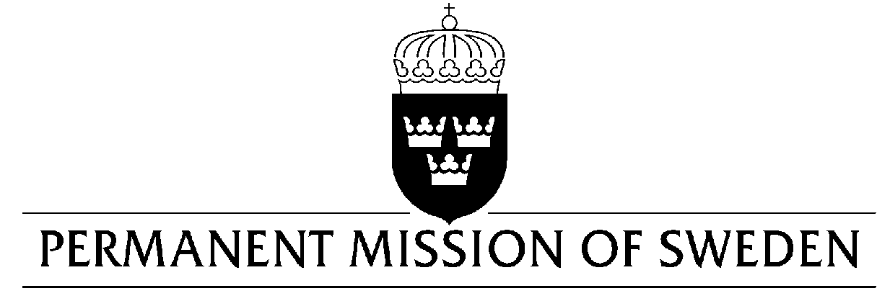
UN Human Rights Council

UPR 30th session

Statement by Sweden in the interactive dialogue on Uzbekistan

Delivered by Counsellor Ms. Anna Envall
Geneva, 9 May 2018 (speaking time 1:30, speaker no. 65)

Mr. President,

Sweden warmly welcomes the delegation of Uzbekistan and extends its thanks for the comprehensive report and the presentation.

The Government of Uzbekistan has taken several positive steps to improve the human rights situation in the country. At least 26 long-time detained human rights defenders have been released since September 2016, and there is a process to review many sentences. However, an unknown number of other individuals are reportedly still being imprisoned on politically motivated charges.

Sweden recommends the Government of Uzbekistan to:

- Release all persons imprisoned on politically motivated charges.

- Bring legal provisions that restrict the right to freedom of expression and freedom of the media in line with Uzbekistan’s international human rights obligations, including allowing effective access to information, also online.

- Adopt legislation on violence against women, in line with international norms and standards.

Sweden wishes the Government of Uzbekistan all success in the current review and in implementing the recommendations.

I thank you Mr. President

