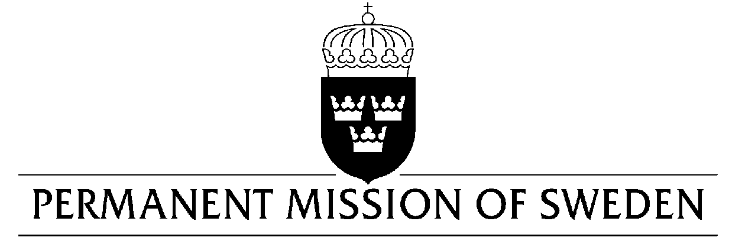
UN Human Rights Council

UPR 30th session

Statement by Sweden in the interactive dialogue on Turkmenistan

Delivered by Counsellor Ms. Anna Envall
Geneva, 7 May 2018 (speaking time 1:35, speaker no. 22)

Mr. President,

Sweden wishes to welcome the delegation of Turkmenistan and extends its thanks for the report and the presentation.
The enforced disappearance of prisoners in Turkmenistan continues and has a systematic character. Sweden recommends the Government of Turkmenistan to:

- Provide information to the families of persons in custody who previously have been reported as having disappeared, including current place of detention and details of custodial sentence.

further Sweden recommends the Government of Turkmenistan to:

- Include a ban on censorship in the Constitution and expand the definition of the ban on censorship in the Law on Mass Media to include every person who makes public communications, in accordance with its international obligations.

- Cease blocking access to internet sites and social media networks.

- Amend the legislation, including the Constitution and the Law on Migration, by including explicit legal guarantees for the right to free exit from, and return to Turkmenistan in accordance with international law.

Sweden wishes the Government of Turkmenistan all success in the current review and in implementing the recommendations.

I thank you Mr. President

