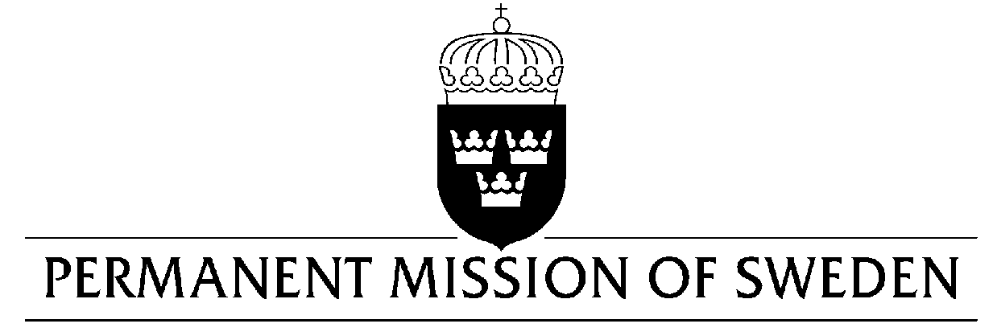
UN Human Rights Council

UPR 30th session

Statement by Sweden in the interactive dialogue on Russian Federation

Delivered by H.E. Mr. Daniel Blockert
Geneva, 14 May 2018 (speaking time 1 minute, speaker no. 5)

Thank you Mr. President,

Sweden wishes to welcome the delegation of the Russian Federation and would like to offer the following recommendations:

- To repeal the legislation on “undesirable organisations” and “foreign agents”.

- To repeal laws that limit freedom of expression online and offline, including the so-called Yarovaya package of counter-terrorism legislation.

- To end the practice of using the broad and vague anti-extremism and counter-terrorism legislation to pursue politically motivated charges.

- To refrain from detaining participants of peaceful demonstrations and to ensure that police officers who use excessive force against protesters are held accountable.

- To end the practice of obstructing peaceful demonstrations by, under politically motivated pretexts, not granting them authorization.

Sweden wishes the Government of the Russian Federation all success in the current review.

I thank you Mr. President

