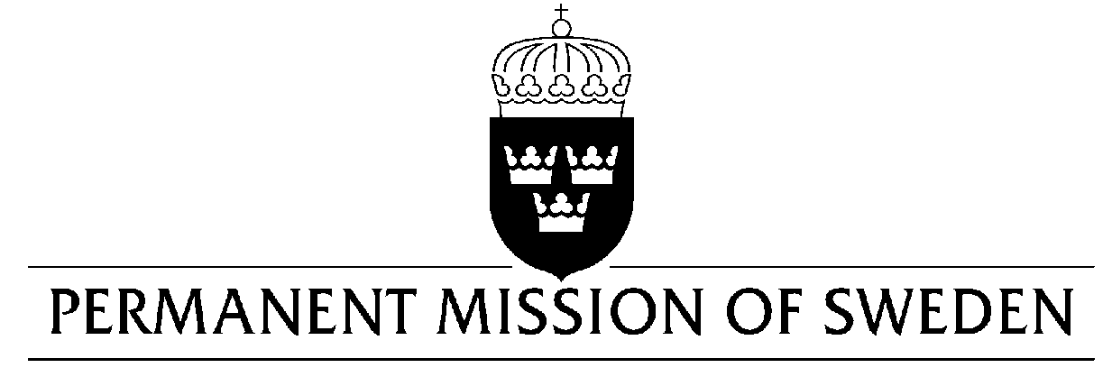
UN Human Rights Council

UPR 30th session

Statement by Sweden in the interactive dialogue on Germany

Delivered by H.E. Ms. Veronika Bard
Geneva, 8 May 2018 (speaking time 1:05, speaker no. 104)

Mr. President,
Sweden warmly welcomes the German delegation and thanks for the comprehensive report and presentation.
Sweden would like to recommend the Federal Government of Germany to:

- Extend the right to return to full-time employment after maternity or paternity leave,

- Review Paragraph 219a StGB, prohibiting information about and advertising on abortion, which, in practice, restricts the prospects for women to undergo an abortion if she so wishes,

- Set up a national compensation fund for transsexual persons who were coerced into sterilisation or unwanted gender reassignment treatment in the years 1981–2011,

- Establish an independent ombudsman office for children with authority to collect and investigate reports of violations and abuses of the rights of the child.
Sweden wishes the Federal Government of Germany all success in the review and in implementing the recommendations.

I thank you Mr. President

