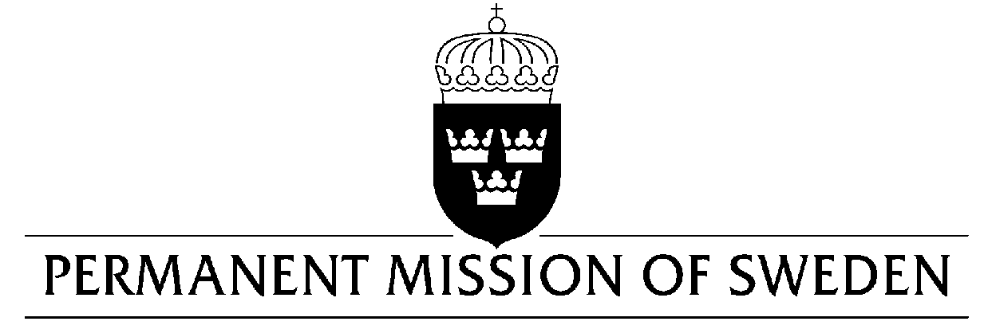
UN Human Rights Council

UPR 30th session

Statement by Sweden in the interactive dialogue on Djibouti

Delivered by Minister-Counsellor Ms. Karin Bolin
Geneva, 10 May 2018 (speaking time 1:15, speaker no. 96)

Thank you Mr. President,

Sweden wishes to welcome the delegation of Djibouti and extends its thanks for the report and the presentation.

Sweden would like to offer the following recommendations to the Government of Djibouti:

- To bring its laws into full conformity with the ICCPR, in particular article 19, and to fully guarantee the rights to freedom of expression and information,

- To revise Article 4 of the law 1/AN/92/2e L, in order to lower requirements for the formation of political parties,

- To revise Decree No. 2015-3016/PR/PM in order to end the exceptional security measures restricting the right to freedom of association in the country,

- To further step-up its efforts in combatting the harmful practice of female genital mutilation/cutting, including by improving monitoring mechanisms in collaboration with both state and non-state actors

Sweden wishes the Government of Djibouti all success in the current review and in implementing the recommendations.

I thank you Mr. President

