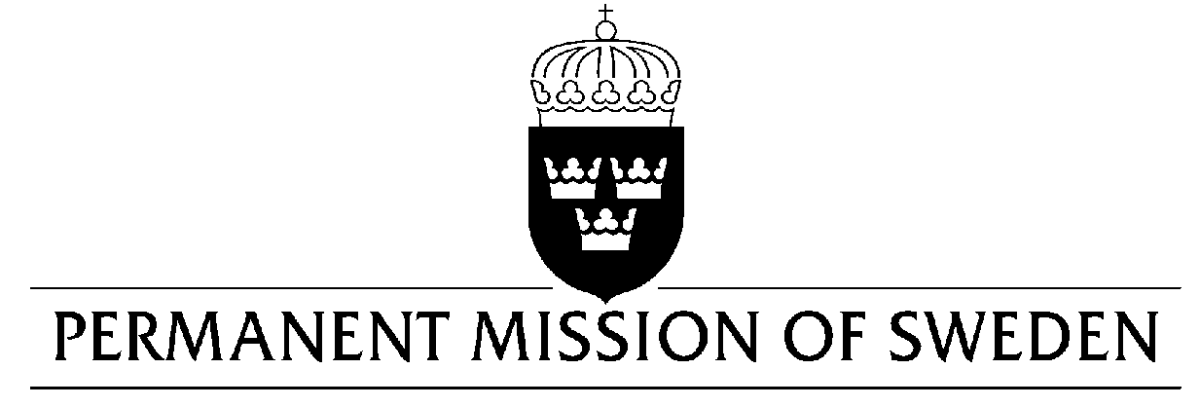
UN Human Rights Council

UPR 30th session

Statement by Sweden in the interactive dialogue on Cuba

Delivered by H.E. Ms. Veronika Bard
Geneva, 16 May 2018 (speaking time 50 seconds, speaker no. 83)

Mr. President,

Sweden welcomes the delegation of Cuba and thanks for the report and the presentation.

Sweden would like to recommend the Government of Cuba to:

- Ratify the ICCPR and the ICESCR without restrictions,

- Issue a standing invitation to the Special Procedures of the Human Rights Council, including all Special Rapporteurs,

- Review legal provisions that restrict the rights of freedom of expression, peaceful assembly and association, and bring them in line with Cuba’s international human rights obligations,

- Bring its electoral legislation in line with international law and standards.

I thank you Mr. President

