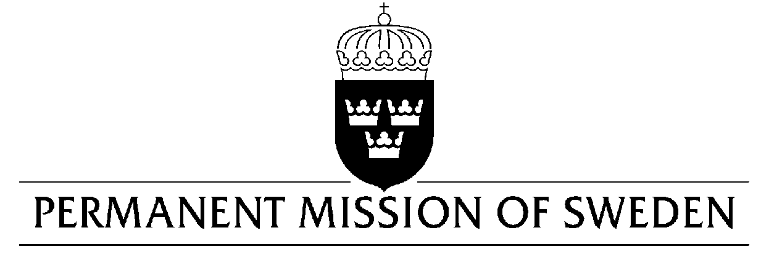
UN Human Rights Council

UPR 30th session

Statement by Sweden in the interactive dialogue on Colombia

Delivered by H.E. Ms. Veronika Bard
Geneva, 10 May 2018 (speaking time 1:20, speaker no. 91)

Mr. President,
Sweden wishes to warmly welcome the delegation of Colombia and extends its thanks for the comprehensive report and presentation.

Sweden would like to recommend the Government of Colombia to:

- Fight impunity and prosecute those responsible for violence, including sexual and gender-based violence, against women and girls.

- Fully implement the existing law pertaining to women’s participation in elections.

- Ensure that human rights defenders are able to carry out their work free from intimidation, threats, harassment and attacks and to guarantee their safety, especially those working in rural conflict-prone areas.

Sweden wishes the Government of Colombia all success in the current review and in implementing the recommendations.

I thank you Mr. President

