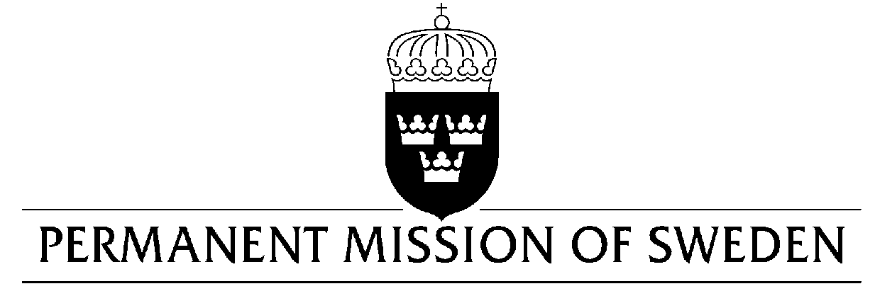
UN Human Rights Council

UPR 30th session

Statement by Sweden in the interactive dialogue on Canada

Delivered by Minister-Counsellor Ms. Karin Bolin
Geneva, 11 May 2018 (speaking time 1:05, speaker no. 76)

Thank you Mr. President,

Sweden wishes to welcome the delegation of Canada and extends its thanks for the report and the presentation. Sweden acknowledges the continued work of the Government of Canada to fulfil its obligations with regard to human rights and encourages further efforts.

Sweden would like to offer the following recommendations:

- To ensure that indigenous peoples have access to the same support, services and ability to exercise their human rights as other Canadian citizens,

- To develop a comprehensive plan to counteract all forms of discrimination against indigenous peoples,

- Sweden welcomes the steps taken by Canada to explicitly prohibit corporal punishment of children in all public and private settings, including in the school and at home. In this regard, Sweden recommends the Government of Canada to enact and implement Bill S-203 as soon as possible.

Sweden wishes the Government of Canada all success in the current review and in implementing the recommendations.

I thank you Mr. President

