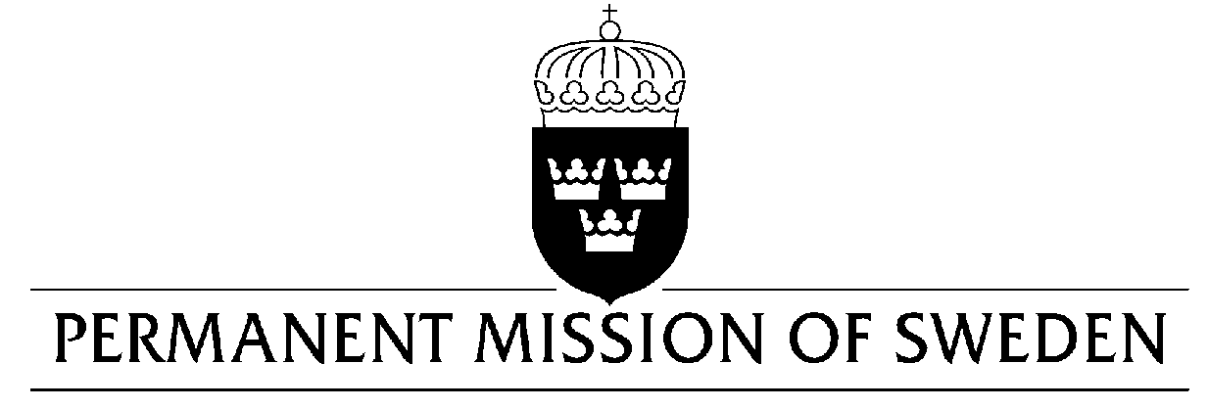
UN Human Rights Council

UPR 30th session

Statement by Sweden in the interactive dialogue on Burkina Faso

Delivered by Minister-Counsellor Ms. Karin Bolin
Geneva, 7 May 2018 (speaking time 1:20, speaker no. 73)

Mr. President,

Sweden wishes to welcome the delegation of Burkina Faso and extends its thanks for the report and the presentation. Sweden welcomes legal reforms that improve the protection and promotion of women’s and girls’ human rights. However, women’s and girls’ enjoyment of their human rights remain frequently restricted due to the lack of implementation of these important laws as well as harmful social practices.

While welcoming progress made, Sweden would like to make the following recommendations to the Government of Burkina Faso:

- To set the minimum age of marriage for both girls and boys at 18 years and take firm action to prevent children from becoming victims of child, early and forced marriage.

- To eradicate female genital mutilation (FGM) and to bring perpetrators to justice.

- To intensify its efforts to implement previously accepted UPR recommendations that relates to ensuring the independence and effectiveness of the judicial system.

Sweden wishes the Government of Burkina Faso all success in the current review and in implementing the recommendations. Sweden remains at your side as technical and financial partners.

I thank you Mr. President

