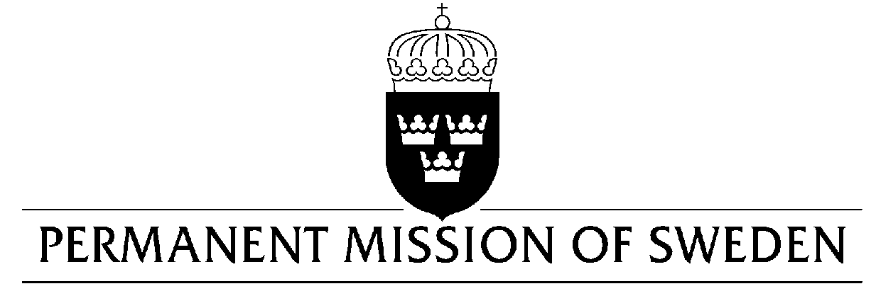
UN Human Rights Council

UPR 30th session

Statement by Sweden in the interactive dialogue on Bangladesh

Delivered by H.E. Mr. Daniel Blockert
Geneva, 14 May 2018 (speaking time 1:05, speaker no. 4)

Mr. President,

Sweden warmly welcomes the delegation of Bangladesh. We acknowledge the important role Bangladesh has played in the face of overwhelming influx of Rohingya refugees deserving solidarity and support from the international community.

Sweden recommends the Government of Bangladesh to:

- Take action against child early and forced marriages with or between children by reformulating the Child Marriage restraint Act 2017 to clarify the gaps in the legislation and to prevent misuse of the “special circumstances” clause,

- Redraft the Digital Security Act in line with international norms and standards for freedom of expression,

- Thoroughly investigate extra-judicial killings, abductions and forced disappearances taking place within law enforcement agencies while also ensuring that the perpetrators are brought to justice.

I thank you Mr. President

