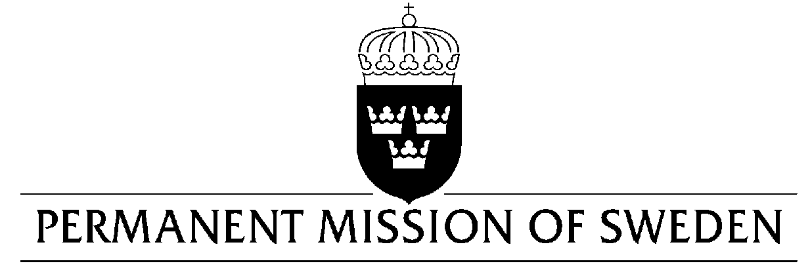
UN Human Rights Council

UPR 30th session

Statement by Sweden in the interactive dialogue on Azerbaijan

Delivered by Minister-Counsellor Ms. Karin Bolin
Geneva, 15 May 2018 (speaking time 1:05, speaker no. 14)

Mr. President,

Sweden wishes to welcome the delegation of Azerbaijan and extends our thanks for the report and the presentation.

Sweden would like to offer the following recommendations:

- Sweden reiterates its recommendation that the Government of Azerbaijan ensures that human rights defenders, lawyers and civil society actors are able to carry out their activities without fear or threat of reprisal, obstruction, legal or administrative harassment,

- To stop all politically motivated legal proceedings against independent civil society actors,

- To amend the Code of Administrative Offenses, Law on Grants and Law on NGOs to eliminate requirements for re-registration and to simplify regulations on access to funding,

- To ensure the right to freedom of expression, including by revoking its decision from 2017 to block the websites of several independent and opposition media,

Sweden wishes the Government of Azerbaijan all success in the current review and in implementing the recommendations.

I thank you Mr. President

