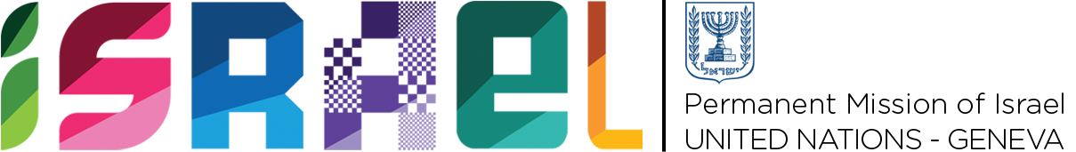 | Check against delivery

Statement on behalf of the State of Israel

UPR WORKING GROUP
30th SESSION - May 2018

Review of the Germany

Thank you, Mr. President.

Israel would like to warmly welcome Germany to the UPR, and to thank it for its report. We take note of Germany´s thorough and inclusive preparation process in view of the third cycle of UPR.

Israel commends Germany for many positive measures taken since the previous review, including: the development of the National Action Plan Against Racism; the passing of the Act to improve the fight against human trafficking and the Act to promote transparency of wage structures; the implementation of the Primary Prevention of Child Sexual Abuse by Juveniles (PPJ) project, and the efforts shown on combating anti-Antisemitism, among others.

Israel would like to make the following recommendations:

- To use the knowledge of the Ministry for Family Affairs to reform the law on transsexuals and to implement a third gender option for intersex and non-binary trans people based on self-determination.
- To ensure inclusivity and accessibility on health-care, judicial and educational services and facilities for persons with disabilities.
- To take further steps to ensure that cases of gender-based violence are reported and properly prosecuted.

Finally, Israel would like to wish Germany a successful UPR.

Thank you.

