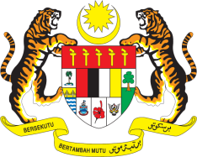

STATEMENT BY MALAYSIA
Review of Djibouti
30th Session of the UPR Working Group
7-18 May 2018

Thank you, Mr. President.

Malaysia warmly welcomes the delegation of Djibouti.

- Malaysia commends Djibouti for the broad consultations involving multiple stakeholders for its UPR, and for the progress in the promotion and protection of human rights in its country as attested by the development of numerous national policies/programmes including the National Gender Policy, National Strategic Action Plan for Children, Master Plan for Education, National Health Development Plan, National Malnutrition Prevention Strategy, National Housing Policy and “Zero Slum” programme all of which are enshrined in the Djibouti Vision 2035. We look forward to the effective implementation of these policies and programmes.

- We also note that the Government has strengthened access and the quality of health services by increasing human resources, upgrading of medical equipment and building capacity for swift and accurate medical diagnoses. We are also encouraged with the introduction of universal insurance coverage, which provides free access to primary health care for those residing in rural areas.

- We encourage Djibouti to undertake further concrete measures to tackle effectively the high maternal mortality rate caused by limited access to health-care services and the lack of trained health-care personnel and prenatal care. In addressing these concerns, we urge Djibouti to ensure a long-term and sustainable funding is allocated for the health care sector to improve and guarantee wide coverage of health-care services especially for the disadvantaged and marginalized groups.

I thank you, Mr. President.

GENEVA
10 May 2018

