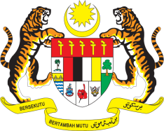

STATEMENT BY MALAYSIA
Review of Azerbaijan
30th Session of the UPR Working Group
7-18 May 2018

Thank you, Mr. President.

Malaysia welcomes Azerbaijan’s engagement in the UPR process and its commitment in the promotion and protection of human rights including efforts in the domestication of ratified human rights conventions into its national legislation.

- Malaysia notes with appreciation Azerbaijan’s commitment to combat human trafficking including the implementation of National Action Plan to Combat Human Trafficking. In further intensifying its efforts, we recommend that Azerbaijan take all necessary steps to eliminate human trafficking and strengthen measures to provide necessary assistance to victims of trafficking by facilitating their reintegration into society.

- Malaysia commends Azerbaijan’s commitment in promoting gender equality and reducing violence against women, through systematic and coherent measures. We recommend the Government continue and intensify its efforts. In this connection, we suggest that the Government consider developing a national action plan to promote women’s rights.

Malaysia wishes Azerbaijan a successful review.

I thank you, Mr. President.

GENEVA
15 May 2018

