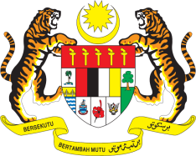

STATEMENT BY MALAYSIA
Review of Russian Federation
30th Session of the UPR Working Group
7-18 May 2018

Thank you, Mr. President.

Malaysia recognises the continued efforts of Russia to improve its legal and structural framework for the advancement of human rights in the country and welcomes Russia’s advances in implementing recommendations from its second UPR.

- As part of our constructive engagement, we would like to offer the following recommendations:

  - Malaysia welcomes Russia’s ratification of the Optional Protocol to the CRC, on the sale of children, child prostitution and child pornography and recommends that the Russian Government continues its efforts to protect the rights of child;

  - Acknowledging Russia’s efforts to address gender-based discrimination and domestic violence, including steps to develop a Federal bill, Malaysia recommends that Russia look into measures to increase protection and support system for victims; and

  - Malaysia also notes reports of continued societal discrimination against minorities. As such, Malaysia recommends that further concrete and effective steps be taken towards protection and social inclusion for all minority groups.

- In concluding, Malaysia wishes Russia every success in its third UPR.

I thank you, Mr. President.

GENEVA
14 May 2018

