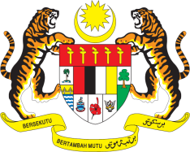

STATEMENT BY MALAYSIA
Review of Uzbekistan
30th Session of the UPR Working Group
7-18 May 2018

Thank you, Mr. President.

Malaysia welcomes strong efforts made by the Government of Uzbekistan to promote and protect human rights, and appreciates the update on the progress made by Uzbekistan since its second UPR in 2013. Malaysia is encouraged to note that Uzbekistan has taken many steps forward in turning its commitments into actions and achieved many promising results.

- Uzbekistan has made important progress in the areas of gender equality and the promotion and protection of the rights of women, children and persons with disabilities. Commendable progress has also been made in the areas of human rights education, social welfare, health, poverty reduction and eradication, among others.

- In the spirit constructive engagement, Malaysia would like to offer the following recommendations for the consideration of the Government of Uzbekistan:

  - Firstly, we recommend Uzbekistan to address corruption in the education system to ensure all hidden and/or informal costs are eliminated; and

3.2 Secondly, we recommend Uzbekistan to undertake necessary steps to attain gender parity in higher education system and address barriers to non-traditional education and career paths for girls and women in the country.

Thank you.

GENEVA
9 May 2018

