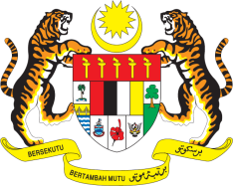

STATEMENT BY MALAYSIA
Review of Cuba
30th Session of the UPR Working Group
7-18 May 2018

Thank you, Mr. President.

Malaysia warmly welcomes the distinguished delegation of Cuba and thanks them for the detailed presentation of their national report.

- Malaysia commends Cuba on its commitment to human rights and its ongoing engagement with the UPR process. As part of our constructive engagement, we are of the view that further attention could be given to niche areas and in this connection, Malaysia would like to offer the following recommendations for the advancement of human rights in Cuba:

  - Promote the effective use of mass media, mobile technologies and the internet to increase awareness on the reduction of disasters;

  - Promote inmates’ access to culture and sports, as part of educational and work programmes that are implemented in prisons; and

  - Continue raising the levels of specialisation of judges, prosecutors and lawyers as well as their professional ethical training.

- In concluding, Malaysia wishes Cuba every success in its review.

GENEVA
16 May 2018

