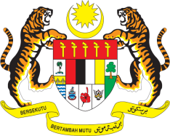

STATEMENT BY MALAYSIA
Review of Turkmenistan
30th Session of the UPR Working Group
7-18 May 2018

Thank you, Mr. President.

Malaysia welcomes the delegation of Turkmenistan to the 30th Session of the UPR Working Group and expresses appreciation for the detailed presentation of their national report.

- Malaysia commends Turkmenistan for the concrete efforts made in socio-economic development of the country, attested by its national development and poverty reduction strategies and the strong emphasis on wide ranging social infrastructure, public healthcare and education for its people. We welcome the recent legislative, institutional and policy developments, including the passing of legislative items related to human rights issues. My delegation also notes with appreciation the Government’s continued measures to raise the awareness of government officials, youth, local authorities, law enforcement bodies and other relevant stakeholders in the field of human rights by holding regularly talks, meetings and round-table discussions. In this regard, we encourage the National Institute for Democracy and Human Rights to continue its efforts in a multi-stakeholder and whole of society approach.

- With all of these developments in mind and in the spirit of constructive engagement, Malaysia would like to recommend the Government of Turkmenistan to continue its efforts in the promotion and protection of human rights in the country by strengthening its national policies and programmes with the aim of further improving the well-being of its people. We encourage for these developments to be further brought to action with the support of appropriate human and financial resources to enable tangible progress to be made at grass root levels.

Thank you, Mr. President.

GENEVA
7 May 2018

