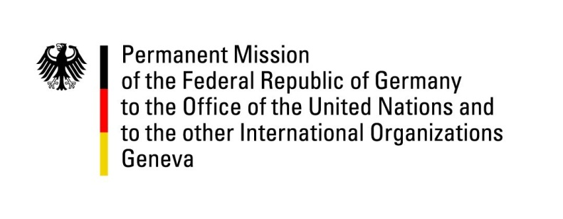

United Nations Human Rights Council

30th Session of the UPR Working Group

Geneva, 9 May 2018

Recommendations and advance questions to
Uzbekistan

Mr. President,
Germany welcomes the delegation of Uzbekistan. Germany commends Uzbekistan for initiating reforms and committing itself to safeguard human rights notably concerning the abolition of child and forced labour, the release of political detainees and the prevention of torture.
However Germany remains concerned by restrictions on civil society and NGOs and ongoing reports of torture in prisons.
Germany recommends:

1) Ensure that all civil society and human rights organizations can work without hindrance by lifting prohibitive registration requirements, burdensome programme approval regulations as well as censorship of printed materials.
2) Amend article 235 of the Criminal Code to ensure that the definition of torture is in full compliance with international Human Rights Law and invite the Special Rapporteur on torture and other cruel, inhuman or degrading treatment or punishment to visit Uzbekistan.
3) Further improve Freedom of press by allowing the media to operate without government interference and ensuring access to all sources of information, including foreign sources and the internet.
Thank you.

GERMAN ADVANCE QUESTIONS TO UZBEKISTAN

- In the 2nd UPR cycle Uzbekistan accepted the German recommendation to allow the ICRC unrestricted access to all penitentiary facilities, including pre-detention facilities, and provide it with appropriate working conditions. What measures have been taken to cooperate with the ICRC on this matter?

- In the 2nd UPR cycle Uzbekistan also accepted the German recommendation to respond to the long-standing request of the Special Rapporteur on torture and other cruel, inhuman or degrading treatment or punishment to visit Uzbekistan. When will this visit take place?

- What plans does Uzbekistan have to ratify OP-CAT?

- What plans does Uzbekistan have to ratify the Rome Statute of the International Criminal Court?

