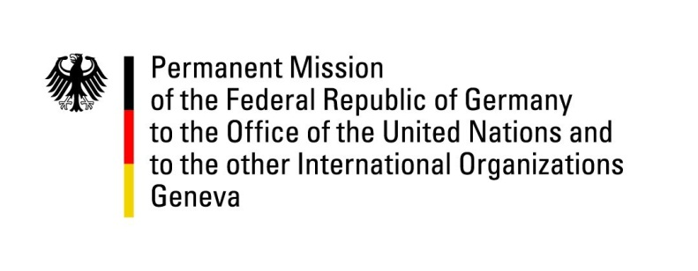

United Nations Human Rights Council
30th Session of the UPR Working Group

Geneva, 7th May 2018

German recommendations and advance questions
to
TURKMENISTAN

Thank you, Mr. President,
Germany welcomes the delegation of Turkmenistan to the UPR. We welcome the launch of the National Human Rights Action Plan as well as the National Action Plans on Gender Equality and against Trafficking in Persons.
However, Germany remains concerned about the continuing deterioration regarding freedom of expression within the last five years. We also condemn the persisting use of torture and ill-treatment in prisons and the high number of individuals remaining forcibly disappeared in the country.
Germany offers the following recommendations:
- Ensure freedom of expression and access to information and stop to interfere with access to the internet as well as censorship of online and print media.
- End arbitrary detention, travel bans, harassment and other acts of intimidation against journalists, media workers and human rights defenders.
- Ratify the OPCAT and allow the ICRC full access to places of detention in accordance with ICRC principles.
- Inform relatives and the public about the whereabouts of all persons who have been under arrest and whose fate is currently unknown and ensure access to lawyers of their choice.

Thank you, Mr. President.
GERMAN ADVANCE QUESTIONS TO TURKMENISTAN
- Which steps have been taken by Turkmenistan to improve freedom of expression and media since the last UPR in 2013? What is the basis for the detention of Human Rights Defenders such as Saparmamed Nepeskuliev, Mansur Mingelov and Gaspar Matalaev?
- In the National Human Rights Action Plan for 2016-2020, Turkmenistan committed to allow new visits by UN Special Procedures. When and to whom is Turkmenistan planning to extend these invitations?
- The National Human Rights Action Plan demands improvements regarding the registration of NGOs (“public organizations”): Which measures have been taken to implement this? When will the comprehensive registration obligations for civil society organizations stipulated in the "Law on Associations" of 2014 be changed to comply with the Action Plan?

