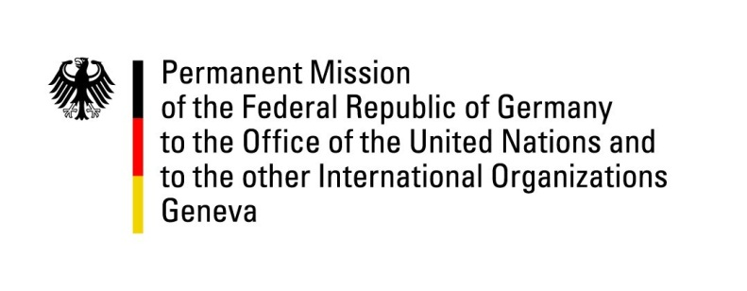

United Nations Human Rights Council

30th Session of the UPR Working Group

Geneva, 14 May 2018

Recommendations and advance questions to the
Russian Federation
Thank you, Mr. President.
Germany welcomes the Russian Federation to the UPR. We welcome positive developments for persons with disabilities.
We recommend:
- Bring the laws on “foreign agents” and “undesirable organizations” in line with international obligations and ensure that civil society can receive support from partners abroad.
- Ensure that LGBTI persons can freely exercise their rights and thoroughly investigate the anti-gay persecution in Chechnya while protecting the witnesses.
- Adopt anti-discrimination legislation encompassing all forms of discrimination and take measures to significantly reduce domestic violence.
- Amend anti-extremist legislation to effectively fight racism and xenophobia while avoiding unjustified human rights restrictions.
- Investigate allegations of torture and inhuman treatment in custody in a transparent manner and bring those responsible to justice.

Thank you, Mr. President.

GERMAN ADVANCE QUESTIONS TO THE RUSSIAN FEDERATION:

- During the second cycle of the UPR in 2013, the Russian Federation committed itself to develop a concept to increase the knowledge and awareness in society, and in particular within State institutions, about human rights obligations of the State and rights of the people. Germany would like to know how well-advanced the efforts for the setting up of such a concept are so far?

- Internet censorship in Russia has skyrocketed last year, with an average of 244 websites having been blocked every day in 2017. What steps will the Russian Federation take to tangibly improve the work environment of bloggers and journalists?

- Could the Russian Federation explain the procedures of how an organization becomes classified as ‘undesirable’ (Federal Law 129-FZ of 23 May 2015 "On amendments of some legislative acts of the Russian Federation"). Are there legal remedies?

