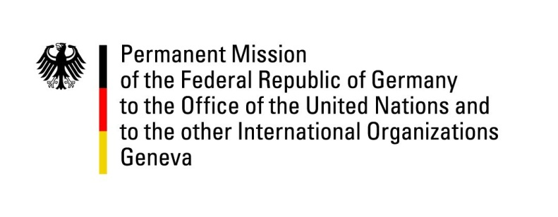

United Nations Human Rights Council
30th Session of the UPR Working Group

Geneva, 10th May 2018

German recommendations and advance questions
to
DJIBOUTI

Mr. President,

Germany welcomes the delegation of Djibouti to the UPR and appreciates the Djibouti’s efforts to promote women’s and children’s rights. We further commend Djibouti’s open and constructive dealing with refugees and migrants in the country.
However, Germany is deeply concerned about violent interactions with protestors and acts of intimidation and reprisals against Human Rights Defenders including the confiscation of passports.
Germany therefore recommends:
- Adopt and implement legislation guaranteeing the protection of Human Rights Defenders and conduct impartial and effective investigations into all cases of alleged attacks and harassment.
- Release all Human Rights Defenders, including journalists and bloggers, detained for exercising their freedom of speech and right to peaceful assembly.
- Improve training programs for security forces to put an end to acts of violent repression of peaceful demonstrations.
- Allow free and independent trade unions in order to protect and promote worker’s rights.

Thank you.

GERMAN ADVANCE QUESTIONS TO DJIBOUTI:
- Which steps have been taken by Djibouti to guarantee the freedom of speech and the freedom to peaceful assembly?
- Which steps have been taken to improve the conditions in prisons?
- Does Djibouti intend to issue a standing invitation to United Nations Special procedures mandate holders?

