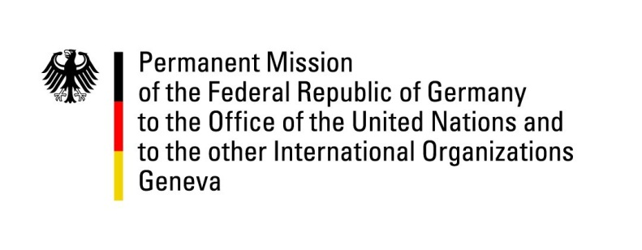

United Nations Human Rights Council

30th Session of the UPR Working Group

Geneva, 16 May 2018

German advance questions and recommendations to

Cuba

Mr. President,
Germany condemns all reprisals of Cuba against human rights defenders, including against individuals in the preparation of this UPR.
Germany recommends:
- Ratify without delay the ICCPR and the ICESCR;
- Fully cooperate with UN human rights mechanisms and grant them unhindered access to Cuba including to government officials, civil society organizations and human rights defenders, to prisons and detention centers.
- Review all legal provisions, including Article 62 of the Constitution which unduly restricts the rights to freedom of expression, peaceful assembly and association, to bring them in line with international law and standards;

- Immediately stop arbitrary detention, imprisonment and harassment of activists who peacefully exercise their rights to freedom of expression, association or peaceful assembly.
Thank you.

German advance questions to Cuba:

- When does Cuba plan to ratify the International Covenant on Civil and Political Rights and the International Covenant on Economic, Social and Cultural Rights signed in 2008?
- Which measures does Cuba plan to take in order to enable independent journalism?
- Can Cuba provide a list of the blogs and websites currently blocked for internet users, and the reasons for these measures?
- Are there any plans to abolish travel restrictions, namely for people on parole, as well as travel restrictions based on a person’s profession, for example in the medical sector?
- What steps is Cuba taking to establish an independent national human rights institution in compliance with the Paris Principles?

