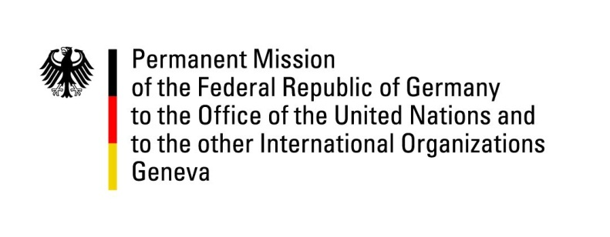

United Nations Human Rights Council

30th Session of the UPR Working Group

Geneva, 10 May 2018

German advance questions and recommendations to

Colombia

Mr. President,
Germany highly appreciates the victims-centered and Human Rights based approach of the Final Peace Accord between the Colombian Government and the former FARC-EP.
Germany recommends:
1) Ensure that activists, human rights defenders and other social and community leaders, especially in rural areas, are equally and effectively protected also in view of the current challenges facing the implementation of the Final Peace Accord, by inter alia ensuring an effective presence of government institutions in all areas of the country.
2) Undertake effective measures to fight the widespread impunity and especially investigate and prosecute human rights violations and infractions of international humanitarian law by, inter alia, increasing the number of judicial police officers, prosecutors and judges dealing with such crimes.
3) Ratify the Optional Protocol on the Convention on the Rights of the Child on a communication procedure and the OP-CAT.
Thank you.

German advance questions to Colombia:
1. How does Colombia ensure that the protection mechanisms laid down in the Peace Accord between the Colombian Government and the former FARC-EP are effectively implemented, such as the National Security Commission and the Special Investigation Unit of the Attorney General?
2. What steps is Colombia taking to ensure access to intelligence information files of violations of human rights as well as to intelligence information in order to contribute to the right to truth justice and reparation in the implementation of the Peace Agreement?
3. How does Colombia ensure that civil society is included in its Follow-up System for the Human Rights Recommendations (Sistema de Seguimiento a las Recomendaciones de Derechos Humanos SISREDH)?

