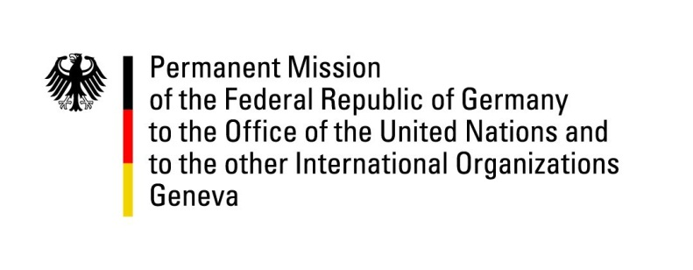

United Nations Human Rights Council

30th Session of the UPR Working Group

Geneva, 11 May 2018

Recommendations and advance questions to
Canada

Thank you, Mr. (Vice) President,

Germany welcomes the delegation of Canada and commends Canada for its strong record on civil and political rights protections.
Germany recommends:

1) Abolish all discriminatory implications of the Indian Act to remove remaining historical discrimination against matrilineal descent regarding aboriginal status.

2) Adopt a comprehensive, measureable, well-resourced, time-bound National Action Plan to address all forms of violence against women and girls and make adequate shelters available to all victims.
3) Expedite the process to ratify the Optional Protocol to the Convention against Torture and Other Cruel, Inhuman or Degrading Treatment or Punishment.

Thank you, Mr. (Vice-) President.

GERMAN ADVANCED QUESTIONS TO CANADA:

- In the 2nd UPR cycle Canada accepted the German recommendation to recognise the right to safe drinking water and sanitation. Which steps has Canada taken to ensure that the legal system guarantees economical, physical and legal accessibility to proper water and sanitation systems for all Canadians including Indigenous and First Nations?

- What steps is Canada taking to develop a comprehensive national strategy to ensure that services for Indigenous people are equitable and adequate, including in particular in relation to education, health care, child welfare and housing?

- What steps has Canada undertaken to ratify OP-CAT?

