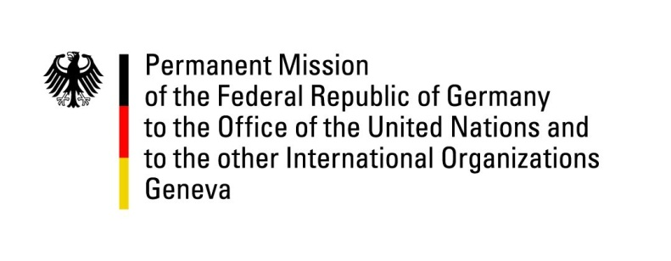

United Nations Human Rights Council

30th Session of the UPR Working Group

Geneva 16th May 2018

German advance questions and recommendations to
Cameroon

Mr. President.

Germany welcomes the delegation of Cameroon and commends the progress made through the legal reform of the Penal Code in 2016, which improves the legal rights of women significantly, especially through penalizing female genital mutilation and extending the penalty in sexual harassment.

However, Germany remains concerned by the persistence of violence against women, particularly in the domestic sphere, and reports about the violation of the freedom of the press and assembly, especially in the Anglophone regions of the country.

Germany offers the following recommendations:
- Prohibition of all forms of domestic violence against women by 2020, especially rape in marriage, as the new Penal Code does not cover all forms of violence against women.
- Compliance with procedural rights in trials, ensuring a fair trial for everyone, also in cases of alleged terrorists.
- Decriminalize same-sex relationships by replacing Art. 347-1 of the Criminal Code followed by a campaign to raise awareness in the public concerning homosexuality.
- Adopt positive measures to guarantee freedom of the press diversity by making available to the public a range of information and ideas, and pluralistic access to media.

Thank you.
Germany’s advance questions to Cameroon:

- In the past, repeated allegations for violating human rights have been made against the security forces of Cameroon. How does the government ensure that human rights standards are met by the police and the military?
- What position does the Cameroonian government have towards international criminal law? Will there be any steps to ratify the Rome Statute in the near future?
- The humanitarian situation in Cameroonian prisons has worsened in recent years due to progressive overcrowding. What measures is the Cameroonian government planning to improve in the short and medium term?

