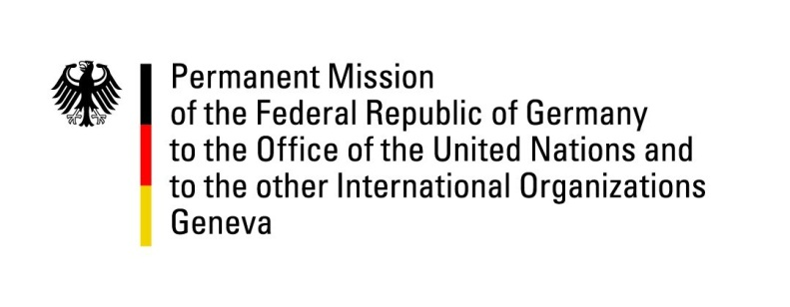

United Nations Human Rights Council

30th Session of the UPR Working Group

Geneva 8. Mai 2018

German advance questions and recommendations to
Cape Verde

Mr. President.

Germany welcomes the delegation of Cape Verde and commends the progress made in protecting children from sexual abuse and exploitation, in particular the revision of the Penal Code in November 2015. We further welcome the efforts to improve the rights of LGBTI persons, including by joining the Equal Rights Coalition in March 2018.

Germany remains concerned by the existing discriminatory stereotypes and patriarchal attitudes concerning the roles of women and men in society, as well as the persistence of violence against women, particularly in the domestic sphere.

Germany recommends:

- Intensify efforts to address discrimination of women in society, in particular to approve a new parity law to help promote equal rights for women in the economic and political sphere;

- Adopt and implement appropriate measures to combat violence against women including sexual and domestic violence by inter alia establishing an adequate number of shelters for victims and providing systematic training on combating gender-based violence to judges, prosecutors, lawyers police officers and health professionals;

- Take effective measures to facilitate the reintegration of former detainees, inter alia by improving access to education, vocational training or other activities for detainees;

- Expedite plans to reform the National Commission on Human Rights and Citizenship in order to comply with the Paris Principles for National Human Rights Institutions and to strengthen its independence.

Thank you.
Germany’s advance questions to Cape Verde:

- Regarding the German recommendation in the second UPR cycle accepted by Cape Verde: What measures have been taken to eliminate the existing discriminatory stereotypes regarding the roles and responsibilities of women and men in family as well as in society at large?

- What is the status of the proposed new parity law?

- What steps are being taken to set up a National Preventive Mechanism as foreseen by the OP-CAT?

