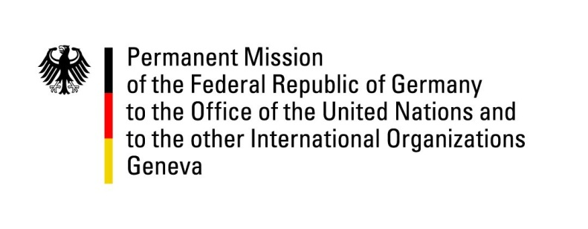

United Nations Human Rights Council
30th Session of the UPR Working Group

Geneva, 7th May 2018

German recommendations and advance questions
to
BURKINA FASO

Mr. President,
Germany welcomes Burkina Faso and commends the improvements made in the process of democratization and in the fight against corruption.
However, Germany remains concerned about the continuing violence against women and girls and that the death penalty remains legally possible.
Germany recommends:
- Amend legislation to fight and legally ban the practice of FGM, other harmful customary practices and domestic violence against women, by inter alia revising the law to define marital rape and to establish an appropriate punishment.
- Establish comprehensive mechanisms to fight early forced marriage by, inter alia, raising the minimum age for marriage, including for traditional marriages, for boys and girls to 18 and making shelters available for people at risk.
- Fully abolish the death penalty, commute all death sentences and ratify the Second Optional Protocol to the ICCPR.
- Make the National Human Rights Commission fully operational and provide it with sufficient financial and human resources, in line with the Paris Principles.
Thank you.

GERMAN ADVANCE QUESTIONS TO BURKINA FASO
- Which steps has Burkina Faso taken in regards to the abolition of the death penalty?

- Which measures are in place to fight terrorism?

- Which steps has Burkina Faso taken to make the national observatory for the prevention of torture operational and to allocate the necessary resources as recommended by the Committee on Enforced Disappearances and the Human Rights Committee?

- Which steps has Burkina Faso taken to ensure a safe and enabling space for all human rights defenders, for example through strong public statements recognizing their legitimate and important role and by holding all those to account who stigmatize the work of human rights defenders?

- How is Burkina Faso implementing legislation and specific programs to protect girls from sexual violence and early pregnancies, and to include comprehensive and effective training programs on sexual and reproductive health in school curricula?

