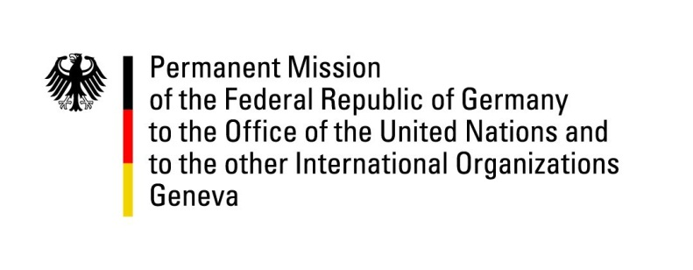

United Nations Human Rights Council

30th Session of the UPR Working Group

Geneva, 14 May 2018

German questions and recommendations to

Bangladesh

Mr. President,
Repeatedly, Germany expressed its appreciation for Bangladesh offering refuge to hundreds of thousands of Rohingya refugees, who were forced to leave their home country, Myanmar. This was an important contribution during an acute humanitarian and human rights crisis.
However, we remain deeply concerned about a worsening of the general human rights situation in Bangladesh, in particular severe restrictions on the media and human rights activists. We continue to be worried about frequent enforced disappearances, extra-judicial killings, torture and further human rights violations from which women and other marginalized groups, including Indigenous people, ethnic and religious minorities and LGBTI, suffer disproportionally. Germany offers the following recommendations:
- Ensure that human rights activists and journalists can exercise their rights without fear, intimidation and harassment by redrafting the planned Digital Security Act, and repealing or amending all laws that violate the rights to freedom of expression, association and peaceful assembly, including the provisions of the Penal Code related to defamation and sedition, the Information Communication Technology Act (in particular Section 57), and the Foreign Donations (Voluntary Activities) Regulation Act, in line with international human rights law;
- End impunity by conducting thorough investigations and criminal prosecutions of human rights violations and abuses against human rights defenders, journalists – in particular secular bloggers – and LGBTI.
- Combat discrimination and gender based violence by reviewing the special provision of the Child Marriage Restrain Act 2017 and implementing legislation that criminalizes all forms of gender based violence effectively.
We thank you, Mr. President.

Questions submitted in advance:
- What is the current status on the withdrawal of reservations against articles 2 and 16.1(c) of the CEDAW that Bangladesh agreed to?
- The use of Section 57 ICT Act puts Freedom of Expression at risk. However, these concerns are not taken into consideration in the current draft of the Digital Security Act. What does the Government of Bangladesh intend to do in order to guarantee Freedom of Expression in the new Digital Security Act?
- What steps does the Government of Bangladesh undertake in order to fight impunity in the recorded cases of extrajudicial killings, enforced disappearances, and torture?

