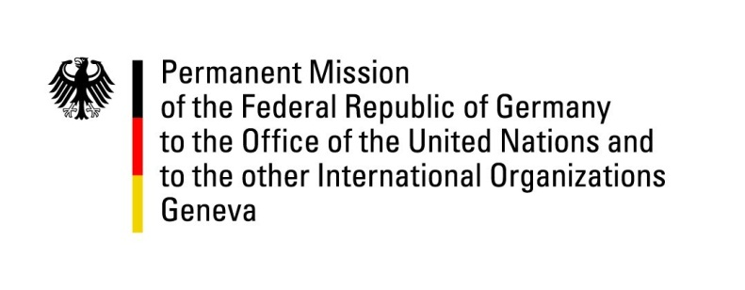

United Nations Human Rights Council
30th Session of the UPR Working Group

Geneva, 15th May 2018

German recommendations and advance questions
to
Azerbaijan

Thank you, Mr. President,
Germany welcomes the delegation of Azerbaijan to the UPR. We commend efforts undertaken to ameliorate the socio-economic conditions of IDPs.
However, Germany remains concerned about ongoing repressions against civil society, independent media, lawyers and activists.
Therefore, Germany offers the following recommendations:
- Bring administrative and legal practice regarding the freedom of assembly in accordance with article 49 of the constitution and article 5 of the law „On Freedom of Assembly“.
- Revise restrictive NGO and grant legislation from early 2014 and bring it in line with international standards.
- Reform of the Ombudsman institution to maintain A status according to the Paris Principles.
- Refrain from any undue interference in the work of lawyers and ensure the effective independence of the Bar Association of Azerbaijan.

Thank you, Mr. President.
GERMAN ADVANCE QUESTIONS TO TURKMENISTAN
- How many allegations of torture have been reported in the reporting period; how many of them have been investigated; how many have been confirmed and led to which consequences?
- With the amendments to the law about legal counsel which came into force on 1 January 2018, the membership in the Bar Association became obligatory for lawyers in order to represent clients in court. What is planned to lower the entrance barrier for the Bar Association and thus to raise the number of barrister lawyers in the country which is currently the lowest per capita in the region?

