Permanent Mission of  The Republic of the  SUDAN  To U.N. Office, Geneva | 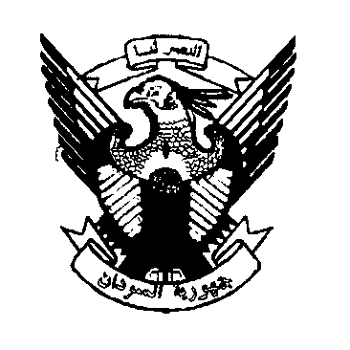 | 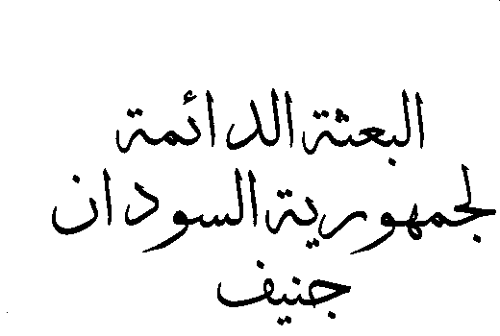

The 30th Session of the UPR Working Group
Statement of the delegation of the Sudan
Review of the Russian Federation Monday ,14 May 2018
Mr. President,
The delegation of the Sudan warmly welcomes the distinguished delegation of the Russian Federation, to this third cycle of the UPR working group and would like to thank them for the comprehensive presentation of the national report.
My delegation commends the commitment and positive engagement of the Government of the Russian Federation with UPR process, and appreciates the recent development since the previous review, in particular the legislative and institutional developments such as, the accession to many treaties like the Marrakesh Treaty to facilitate Access to Published Works For Persons Who Are Blind, Visually Impaired or Otherwise Print Disabled in 2017 as well as the Optional Protocol to the Convention the Rights of the Child on the sale of children, child prostitution and child pornography and the establishment of the Presidential Commissioner for Children's Rights.
My delegation would like to present to the Russian Federation the following two recommendations:
1 To continue its efforts to implement the national strategy on action for women for the period 2017-2022 , that aimed to create conditions for the full and equal participation of women in the political, economic, social and cultural domains of social life.
2. To continue its efforts to upgrade its judicial system.
Thank you

