Permanent Mission of  The Republic of the  SUDAN  To U.N. Office, Geneva | 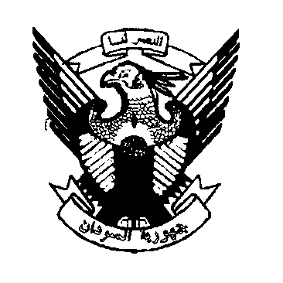 | 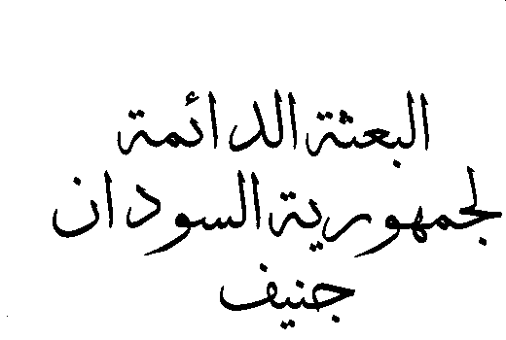

The 30th Session of the UPR Working Group
Statement of the delegation of the Sudan
Review of Canada, Friday 11 May 2018
Mr. President
The delegation of the Sudan welcomes the distinguished delegation of Canada, participating in this 30th session of the UPR Working Group and would like to thank the head of the delegation for the comprehensive presentation of the National report.
My delegation has taken note of the national report under review and would like to provide the following (4) recommendations:
1/ To promote and protect the human rights of its indigenous people in particular economic, social and cultural rights,
2/ to eliminate any form of racial discrimination, Xenophobia and related intolerance against Muslims and the people of the African descent,
3/ to end excessive use of force by police, when responding to cases involving vulnerable people of African descent, such as those who mentally ill,
In conclusion, Sudan delegation wishes Canada a successful review

