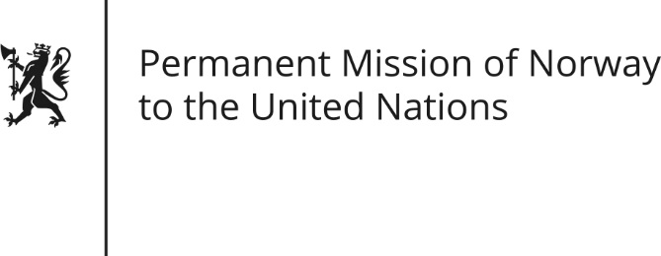

STATEMENT by Ambassador Hans Brattskar

30th Session of the Universal Periodic Review

8 May 2018

Check against delivery

President,
Norway welcomes Germany’s participation in the UPR and [commends Germany’s commitment to comply with international obligations and promote human rights. We] would [also] like to commend Germany’s active and constructive role as a member in the Human Rights Council. We are pleased that many positive steps have been taken since the last review.
Germany has made efforts to improve gender equality. However, Norway recommends that Germany increases the public awareness of the existence and purpose of the General Equal Treatment Act, and ensures its full implementation. Furthermore, we also recommend Germany to accelerate their efforts to provide women and men with equal opportunities in the labour market, for example by improving the availability and affordability of childcare.
Thank you.

