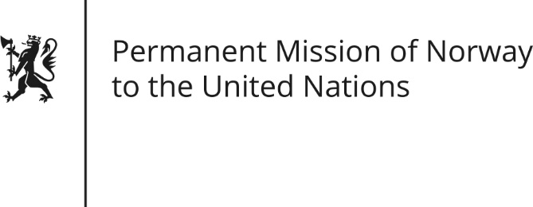

STATEMENT by Senior Adviser Ellen Stie

30th Session of the Universal Periodic Review

9 May 2018

Check against delivery

President,
Norway welcomes Uzbekistan’s participation in the UPR and notes the positive steps taken since its last review, including greater openness and international engagement. The release of political prisoners and [removal of persons from black lists;] the increasing freedom of the press [and the progress made on abolishing forced labour in the cotton harvest are all positive first steps.]
Norway remains concerned about restrictions on civil society and freedom of expression, association and belief.
Norway recommends that Uzbekistan:
1) Adopt concrete measures to ensure the legitimate exercise of the rights to freedom of expression, association and belief;
2) Carry out judicial and penitentiary reform in accordance with international law;
3) Invite the United Nations Special Rapporteurs on torture and human rights defenders.
Thank you.

