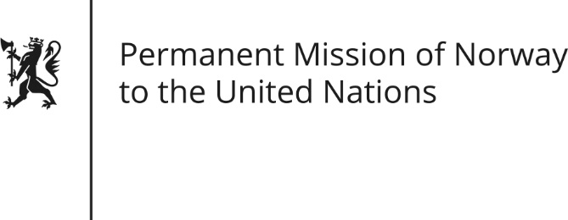

STATEMENT by First Secretary Paul Ø. Bjørdal

30th Session of the Universal Periodic Review

Turkmenistan

7 May 2018

Check against delivery
Mr President,
Norway welcomes Turkmenistan’s participation in the UPR. We remain deeply concerned about the human rights situation and recommends that Turkmenistan:

1) Allow unhindered access to enforced disappeared persons by international monitoring bodies, including UN representatives and Special Procedures; and provide information on their whereabouts;
2) Facilitate a visit by the UN Special Rapporteur on Torture and the Working Group on Arbitrary Detentions;
3) Ratify the Optional Protocol to the Convention against Torture (OPCAT);
4) Take immediate legal action to reverse policy on restricting the rights of everyone to leave and return to their own country;
5) Release immediately and unconditionally all persons imprisoned as a result of peaceful exercise of freedom of expression, collection and distribution of information, and journalistic activity;
6) Stop threats, physical attacks and arbitrary detention and conviction of human rights defenders and individuals for their exercise of freedom of expression and assembly.

Thank you.

