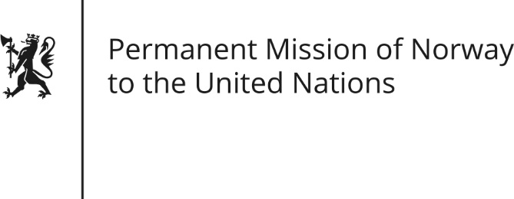

STATEMENT by Minister Counsellor Herborg F. Alvsaaker

30th Session of the Universal Periodic Review

14 May 2018

Check against delivery

President,
Norway welcomes (The People’s Republic of) Bangladesh’s participation in the UPR. Bangladesh has made remarkable social and economic progress, (including poverty reduction and girls’ education.)
(Norway however remains concerned about the safety for human rights defenders and freedom of expression.)
Norway recommends:
1) Ensure that human right defenders, journalists and civil society (have a safe and enabling environment and) can operate freely without fear of reprisals.
2) Review and redraft the proposed Digital Security Act to ensure online freedom of expression.
3) Investigate all allegations of human rights violations by the police and security forces and take legal steps so that those responsible (for enforced disappearances, custodial torture and extrajudicial killings) are held accountable.
4) Take concrete measures to prevent and protect women from domestic violence, ensure (effective) access to legal recourse and hold perpetrators to account.
5) Establish effective protection against discrimination, harassment and violence against sexual minorities.
Thank you.

