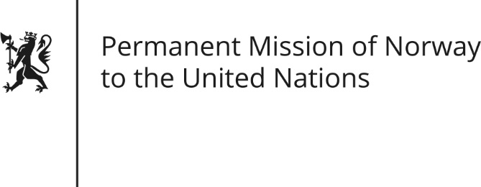

STATEMENT by Senior Adviser Guro Camerer

30th Session of the Universal Periodic Review

11 May 2018

Check against delivery

President,
Norway welcomes the Canadian delegation [and notes the positive steps taken since its last review], [including the efforts taken to strengthen the rights of indigenous peoples].
Norway recommends that Canada introduce a concrete action plan to combat all forms of violence against women and girls, [covering all levels of government, and with particular focus on Indigenous women and girls].
We recommend that the coordination on human rights implementation across levels of government be strengthened in order to ensure better implementation domestically.
Norway recommends that Canada take action to ensure equal access to abortion and comprehensive sexuality education across provinces and territories.
[Recognizing the progress made,] Norway recommends that Canada ensure the full equality for Indigenous Peoples in the protection of their international human rights to health, education and welfare, [and particularly access to clean drinking water].
[Finally, Norway recommends that Canada ratify the Optional Protocol to the Convention against Torture and other Cruel, Degrading and Inhuman Treatments or Punishments].
Thank you.

