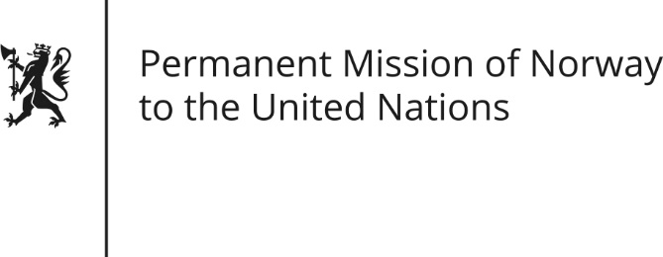

STATEMENT by Ambassador Hans Brattskar

30th Session of the Universal Periodic Review

10 May 2018

Check against delivery

President,
Norway welcomes Colombia’s participation in the UPR and commends the positive steps taken since the last review. (We commend the peace efforts of the Colombian government with the FARC and the ELN, which represents a unique opportunity to strengthen the human rights situation in Colombia). Norway recommends Colombia to:
1. Implement the Transitional Justice System, the Commission for the Clarification of Truth, Coexistence and Non-Repetition and the Unit for the Search of Persons declared as Disappeared as agreed in the Peace Agreement;
2. Prevent and investigate all attacks against human rights defenders and community leaders (,including, trade unionists, indigenous leaders and environmentalist defenders) and bring those responsible to justice;
3. Strengthen measures to prevent and punish domestic violence and violence against women, including by improving the investigation, prosecution and prevention of rape and sexual violence against girls.
Thank you.

